WT_Application XML Reference

Element | Implementation | Attributes | Options
WTAPPLICATION | ::CApplication | name
WTBODIES | ::CBodies
WTCOLOR | ::CColor | name
 |  | value
WTCOLORS | ::CColors
WTCOMPONENTS | ::CComponents
WTDATASTORE | ::CDataStore | name
 |  | owner
 |  | prefix
WTDATASTORES | ::DataStores
WTJAVAS | ::CJavas
WTLANGCODES | ::CLangCodes
WTPAGES | ::CPages
WTPLUGIN | ::CPlugIn | name
 |  | type | body, comp, java, lang, page, proc, table, template, trans
WTPROCEDURES | ::CProcedures
WTSTYLE | ::CStyle | name
 |  | value
WTSTYLES | ::CStyles
WTTABLES | ::CTables
WTTEMPLATES | ::CTemplates
WTTRANSLATIONS | ::CTranslations
WTWEBSITE | ::CWebSite | name
WTWEBSITES | ::CWebSites

WT_Application Object Model

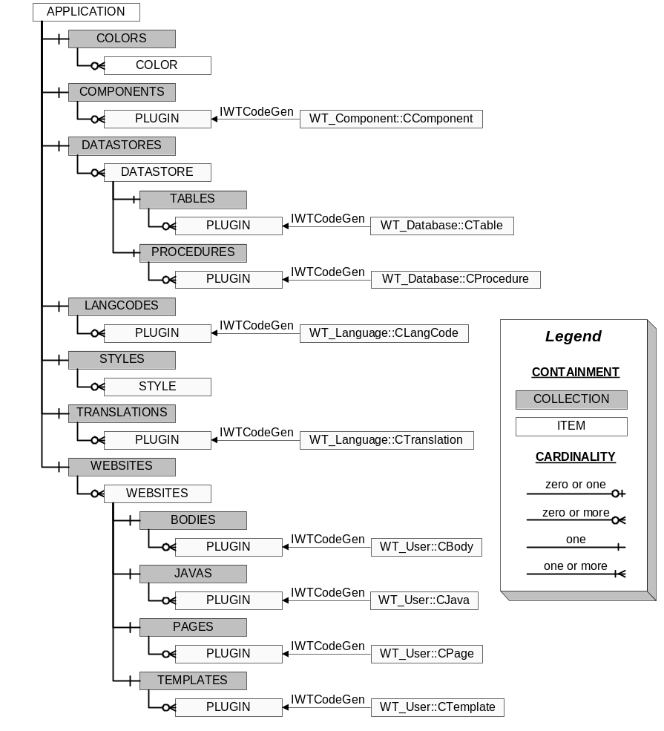

WT_Database XML Reference

Element | Implementation | Attributes | Options
WTCOLUMN | ::CColumn | name
 |  | type | address, auditid, auditdate, code, compute, email, foreignkey, identity, name, none, phone, url,
 |  | datatype | bit, char, datetime, int, money, nchar, nvarchar, smallint, tinyint, varchar
 |  | length
 |  | reftable
 |  | refcolumn
 |  | value
WTCOLUMNS | ::CColumns
WTDECLARE | ::CDeclare | name
 |  | type | address, auditid, auditdate, constant, email, identity, name, none, phone, procedure, url
 |  | datatype | bit, char, datetime, int, money, nchar, nvarchar, smallint, tinyint, varchar
 |  | length
 |  | value
WTDECLARES | ::CDeclares
WTINDEX | ::CIndex | name
 |  | type | foreign, primary, unique
WTINDEXES | ::CIndexes
WTPARAMETER | ::CParameter | name
 |  | type | input, inputoutput, output
 |  | datatype | bit, char, datetime, int, money, nchar, nvarchar, smallint, tinyint, varchar
 |  | length
 |  | value
WTPARAMETERS | ::CParameters
WTPROCEDURE | ::CProcedure | name
 |  | type | add, custom, delete, enum, exec, fetch, find, init, list, update
 |  | comment
 |  | nocount | true, false
 |  | xml | true, false
WTPROCEDURES | ::CProcedures
WTTABLE | ::CTable | name
 |  | type | association, child, parent
 |  | comment
 |  | alias
WTTABLES | ::CTables

WT_Database Object Model

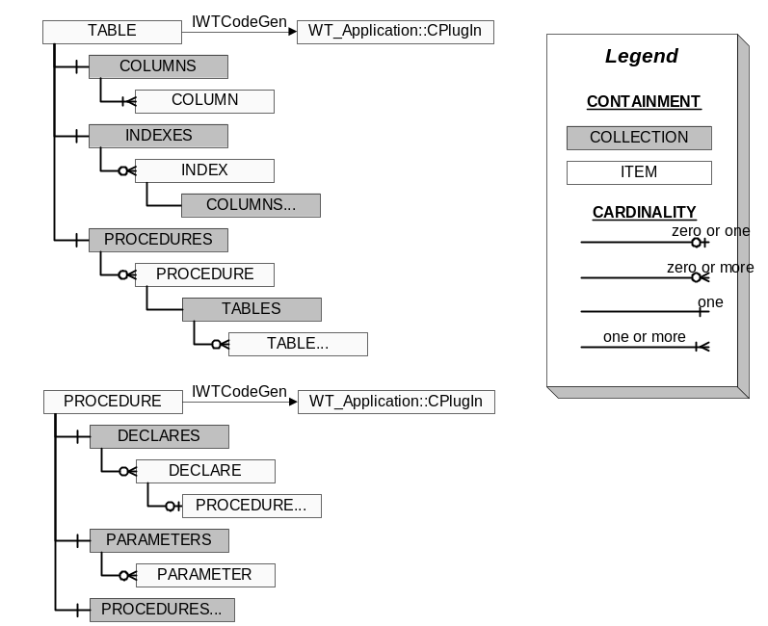

…AddXML SQL/XML Cross Reference

file: ice_AuthUser_AddXML.prc | file: AuthUser_AddXML.xml
EXEC [WTApp].ice_CheckProc 'ice_AuthUser_AddXML'
GO

CREATE PROCEDURE [WTApp].ice_AuthUser_AddXML ( | <WTPROCEDURE name=”AuthUser_AddXML” type=”Add” xml=”True”>
 | <WTPARAMETERS>
@Email nvarchar(255), | <WTPARAMETER name=”Email” type=”input” datatype=”nvarchar” Length=”255”/>
@NameFirst nvarchar(15), | <WTPARAMETER name=”NameFirst” type=”input” datatype=”nvarchar” Length=”15”/>
@NameMiddle nvarchar(15), | <WTPARAMETER name=”NameMiddle” type=”input” datatype=”nvarchar” Length=”15”/>
@NameLast nvarchar(15), | <WTPARAMETER name=”NameLast” type=”input” datatype=”nvarchar” Length=”15”/>
@AuthSites varchar(255), | <WTPARAMETER name=”AuthSites” type=”input” datatype=”nvarchar” Length=”255”/>
@UserID int | <WTPARAMETER name=”UserID” type=”input” datatype=”int”/>
) | </WTPARAMETERS>
AS
SET NOCOUNT ON | <WTPROCEDURE name=”AuthUser_AddXML” nocount=”True”>
 | <WTDECLARES>
DECLARE @mNow datetime, | <WTDECLARE name=”Now” datatype=”datetime” … />
@mNewID int, | <WTDECLARE name=”NewID” datatype=”int” … />
@mPswd nvarchar(30) | <WTDECLARE name=”Pswd” datatype=”nvarchar” length=”30” … />
SET @mNow = GETDATE() | <WTDECLARE name=”Now” … type=”audit date””/>
 | <WTDECLARE name=”Pswd” … type=”procedure”/>
--get the default password | <WTPROCEDURE name=”GetPassword” type=”exec”>
EXEC [WTApp].ice_GetPassword | --get the default password
 | <WTPARAMETERS>
@mPswd OUTPUT | <WTPARAMETER name=”Password” type=”output” value=”@mPswd”/>
 | </WTPARAMETERS>
 | </WTDECLARE>
 | </WTDECLARES>
 | <WTTABLES>
 | <WTTABLE name=”AuthUser” alias=”au”>
--add the record | add the record
INSERT INTO AuthUser ( | <WTCOLUMNS>
Email, | <WTCOLUMN name=”Email” … />
Pswd, | <WTCOLUMN name=”Pswd” … />
NameFirst, | <WTCOLUMN name=”NameFirst” … />
NameMiddle, | <WTCOLUMN name=”NameMiddle” … />
NameLast, | <WTCOLUMN name=”NameLast” … />
AuthSites, | <WTCOLUMN name=”AuthSites” … />
CreateDate, | <WTCOLUMN name=”CreateDate” … />
CreateID, | <WTCOLUMN name=”CreateID” … />
ChangeDate, | <WTCOLUMN name=”ChangeDate” … />
ChangeID | <WTCOLUMN name=”ChangeID” … />
)
VALUES
(
@Email, | <WTCOLUMN name=”Email” … value=”@Email”/>
@mPswd, | <WTCOLUMN name=”Pswd” … value=”@mPswd”/>
@NameFirst, | <WTCOLUMN name=”NameFirst” … value=”@NameFirst”/>
@NameMiddle, | <WTCOLUMN name=”NameMiddle” … value=”@NameMiddle”/>
@NameLast, | <WTCOLUMN name=”NameLast” … value=”@NameLast”/>
@AuthSites, | <WTCOLUMN name=”AuthSites” … value=”@AuthSites”/>
@mNow, | <WTCOLUMN name=”CreateDate” … value=”@mNow”/>
@UserID, | <WTCOLUMN name=”CreateID” … value=”@UserID”/>
@mNow, | <WTCOLUMN name=”ChangeDate” … value=”@mNow”/>
@UserID | <WTCOLUMN name=”ChangeID” … value=”@UserID”/>
) | </WTCOLUMNS>
 | </WTTABLE>
 | </WTTABLES>
 | <WTDECLARES>
SET @mNewID = @@IDENTITY | <WTDECLARE name=”NewID” … type=”identity”/>
 | </WTDECLARES>
 | <WTPROCEDURES>
--send the email out | <WTPROCEDURE name=”AuthUser_ResetPassword” type=”exec”>
EXEC [WTApp].ice_AuthUser_ResetPassword | --send the email out
 | <WTPARAMETERS>
@mNewID, | <WTPARAMETER name=”NewID” type=”input” value=”@mNewID”/>
1 | <WTPARAMETER name=”NewUser” type=”input” value=”1”/>
 | </WTPARAMETERS>
 | </WTPROCEDURE>
--return the new record | <WTPROCEDURE name=”AuthUser_FetchXML” type=”exec”>
EXEC [WTApp].ice_AuthUser_FetchXML | --return the new record
 | <WTPARAMETERS>
@mNewID, | <WTPARAMETER name=”AuthUserID” type=”input” value=”@mNewID”/>
@UserID | <WTPARAMETER name=”UserID” type=”input” value=”@UserID”/>
 | <WTPARAMETERS>
 | </WTPROCEDURE>
 | </WTPROCEDURES>
GO | </WTPROCEDURE>

…Delete SQL/XML Cross Reference

file: ice_AuthUser_Delete.prc | file: AuthUser_Delete.xml
EXEC [WTApp].ice_CheckProc 'ice_AuthUser_Delete'
GO

CREATE PROCEDURE [WTApp].ice_AuthUser_Delete ( | <WTPROCEDURE name=”AuthUser_Delete” type=”Delete” xml=”False”>
 | <WTPARAMETERS>
@AuthUserID int, | <WTPARAMETER name=”AuthUserID” type=”input” datatype=”int”/>
@UserID int | <WTPARAMETER name=”UserID” type=”input” datatype=”int”/>
) | </WTPARAMETERS>
AS
SET NOCOUNT ON | <WTPROCEDURE name=”AuthUser_Delete” nocount=”True”>
 | <WTTABLES>
--delete requested record | <WTTABLE name=”AuthUser” alias=”au”>
DELETE AuthUser | delete requested record
 | </WTTABLE>
 | </WTTABLES>
WHERE AuthUserID = @AuthUserID | ???
 | <WTPROCEDURES>
--delete the user from all stores | <WTPROCEDURE name=”AuthUserStore_DeleteByAuthUser” type=”exec”>
EXEC [WTApp].ice_AuthUserStore_DeleteByAuthUser | --delete the user from all stores
 | <WTPARAMETERS>
@AuthUserID, | <WTPARAMETER name=”AuthUserID” type=”input” value=”@AuthUserID”/>
@UserID | <WTPARAMETER name=”UserID” type=”input” value=”@UserID”/>
 | </WTPARAMETERS>
 | </WTPROCEDURE>
--delete the user from all malls | <WTPROCEDURE name=”AuthUserMall_DeleteByAuthUser” type=”exec”>
EXEC [WTApp].ice_AuthUserMall_DeleteByAuthUser | --delete the user from all malls
 | <WTPARAMETERS>
@AuthUserID, | <WTPARAMETER name=”AuthUserID” type=”input” value=”@AuthUserID”/>
@UserID | <WTPARAMETER name=”UserID” type=”input” value=”@UserID”/>
 | </WTPARAMETERS>
 | </WTPROCEDURE>
 | </WTPROCEDURES>
GO | </WTPROCEDURE>

…FetchXML SQL/XML Cross Reference

file: ice_AuthUser_FetchXML.prc | file: AuthUser_FetchXML.xml
EXEC [WTApp].ice_CheckProc 'ice_AuthUser_FetchXML'
GO

CREATE PROCEDURE [WTApp].ice_AuthUser_FetchXML ( | <WTPROCEDURE name=”AuthUser_FetchXML” type=”Fetch” xml=”True”>
 | <WTPARAMETERS>
@AuthUserID int, | <WTPARAMETER name=”AuthUserID” type=”input” datatype=”int”/>
@UserID int | <WTPARAMETER name=”UserID” type=”input” datatype=”int”/>
) | </WTPARAMETERS>
AS
SET NOCOUNT ON | <WTPROCEDURE name=”AuthUser_FetchXML” nocount=”True”>
 | <WTTABLES>
 | <WTTABLE name=”AuthUser” alias=”au”>
--return the record | return the record
 | <WTCOLUMNS>
SELECT AuthUserID, | <WTCOLUMN name=”AuthUserID” />
Email, | <WTCOLUMN name=”Email” />
NameFirst, | <WTCOLUMN name=”NameFirst” >
NameMiddle, | <WTCOLUMN name=”NameMiddle” />
NameLast, | <WTCOLUMN name=”NameLast” />
AuthSites, | <WTCOLUMN name=”AuthSites” />
CreateDate, | <WTCOLUMN name=”CreateDate” />
CreateID, | <WTCOLUMN name=”CreateID” />
ChangeDate, | <WTCOLUMN name=”ChangeDate” />
ChangeID | <WTCOLUMN name=”ChangeID” />
 | </WTCOLUMNS>
FROM AuthUser (NOLOCK) | <WTTABLE name=”AuthUser” …>
 | </WTTABLE>
 | </WTTABLE>
WHERE AuthUserID = @AuthUserID | ???
FOR XML AUTO | <WTPROCEDURE name=”AuthUser_FetchXML” xml=”True”>
 | </WTCOLUMNS>
GO | </WTPROCEDURE>

…UpdateXML SQL/XML Cross Reference

file: ice_AuthUser_UpdateXML.prc | file: AuthUser_UpdateXML.xml
EXEC [WTApp].ice_CheckProc 'ice_AuthUser_UpdateXML'
GO

CREATE PROCEDURE [WTApp].ice_AuthUser_UpdateXML ( | <WTPROCEDURE name=”AuthUser_UpdateXML” type=”Update” xml=”True”>
 | <WTPARAMETERS>
@AuthUserID int, | <WTPARAMETER name=”AuthUserID” type=”input” datatype=”int”/>
@Email nvarchar(255), | <WTPARAMETER name=”Email” type=”input” datatype=”nvarchar” Length=”255”/>
@NameFirst nvarchar(15), | <WTPARAMETER name=”NameFirst” type=”input” datatype=”nvarchar” Length=”15”/>
@NameMiddle nvarchar(15), | <WTPARAMETER name=”NameMiddle” type=”input” datatype=”nvarchar” Length=”15”/>
@NameLast nvarchar(15), | <WTPARAMETER name=”NameLast” type=”input” datatype=”nvarchar” Length=”15”/>
@AuthSites varchar(255), | <WTPARAMETER name=”AuthSites” type=”input” datatype=”nvarchar” Length=”255”/>
@UserID int | <WTPARAMETER name=”UserID” type=”input” datatype=”int”/>
) | </WTPARAMETERS>
AS
SET NOCOUNT ON | <WTPROCEDURE name=”AuthUser_UpdateXML” nocount=”True”>
 | <WTDECLARES>
DECLARE @mNow datetime | <WTDECLARE name=”Now” datatype=”datetime” … />
SET @mNow = GETDATE() | <WTDECLARE name=”Now” … type=”audit date””/>
 | </WTDECLARES>
 | <WTTABLES>
 | <WTTABLE name=”AuthUser” alias=”au”>
--update the record | update the record
UPDATE AuthUser | <WTCOLUMNS>
SET Email = @Email, | <WTCOLUMN name=”Email” value=”@Email”/>
NameFirst = @NameFirst, | <WTCOLUMN name=”NameFirst” value=”@NameFirst”/>
NameMiddle = @NameMiddle, | <WTCOLUMN name=”NameMiddle” value=”@NameMiddle”/>
NameLast = @NameLast, | <WTCOLUMN name=”NameLast” value=”@NameLast”/>
AuthSites = @AuthSites, | <WTCOLUMN name=”AuthSites” value=”@AuthSites”/>
ChangeDate = @mNow, | <WTCOLUMN name=”ChangeDate” value=”@mNow”/>
ChangeID = @UserID | <WTCOLUMN name=”ChangeID” value=”@UserID”/>
 | </WTCOLUMNS>
 | </WTTABLE>
WHERE AuthUserID = @AuthUserID | ???
 | </WTTABLES>
 | <WTPROCEDURES>
--return the updated record | <WTPROCEDURE name=”AuthUser_FetchXML” type=”exec”>
EXEC [WTApp].ice_AuthUser_FetchXML | --return the updated record
 | <WTPARAMETERS>
@AuthUserID, | <WTPARAMETER name=”AuthUserID” type=”input” value=”@AuthUserID”/>
@UserID | <WTPARAMETER name=”UserID” type=”input” value=”@UserID”/>
 | <WTPARAMETERS>
 | </WTPROCEDURE>
 | </WTPROCEDURES>
GO | </WTPROCEDURE>

